**Business Case: Target SQL**

This business case has data of 100k orders from 2016 to 2018 made at Target, Brazil. It is Americas leading retailer business chain.

Data is available in 8 tables, which gives information about orders from different dimensions like status of order, payment details, location and time of the order , customer who made the purchase, items in the order, product details, seller information of the products, order reviews etc.

**Analysis**

**1. Initial exploration of dataset**

1.1 Show all the tables and all the columns present in each table along with its data type.

Query:

SELECT

  table_schema,

  table_name,

  column_name,

  data_type

FROM

  `target`.INFORMATION_SCHEMA.COLUMNS;

Result:

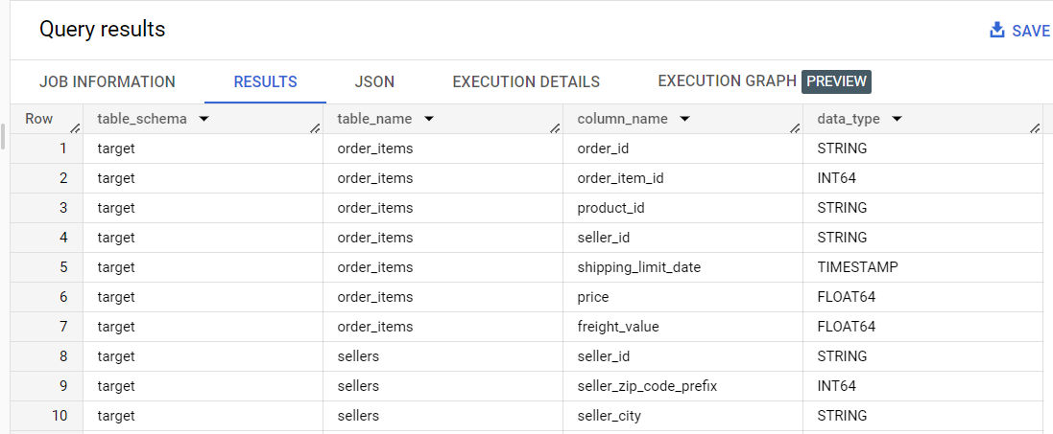

* 1. For which time period the data is given.

Query:

SELECT

  MIN(DATE(order_purchase_timestamp)) AS first_date,

  MAX(DATE(order_purchase_timestamp)) AS last_date

FROM

  `target.orders`;

Result:

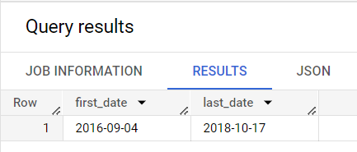

* 1. From which Cities and States , orders were placed during the given period.

Query:

SELECT

  DISTINCT c.customer_state , c.customer_city

FROM

  `target.customers` c

RIGHT JOIN

  `target.orders` o

USING

  (customer_id)

ORDER BY

  c.customer_state , c.customer_city;

Result:

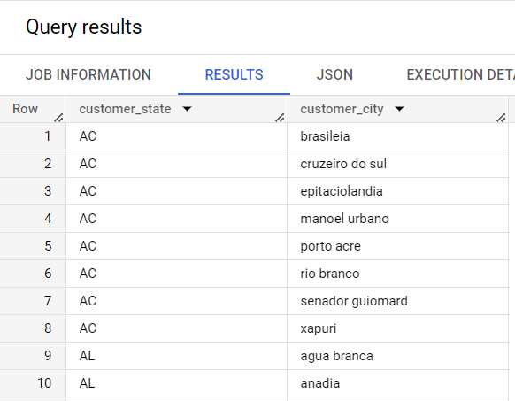

* 1. What is distribution of total orders as per their status?

Query:

SELECT

  order_status,

  COUNT(*) AS orders_count

FROM

  `target.orders`

GROUP BY

  order_status

ORDER BY

  orders_count DESC;

Result:

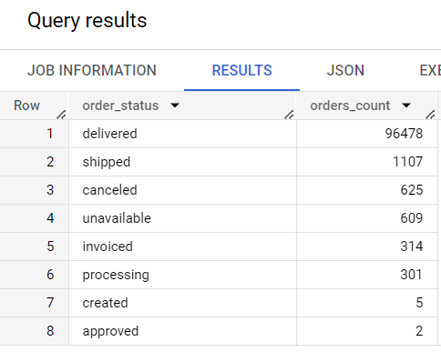

* 1. How is the order value of each order is calculated in payment table, Is it addition of price and freight for each item in the order.

*(Used order items and payment table)*

SELECT

  order_id,   total_price, total_freight,

  total_price + total_freight AS total_order_value

FROM ( SELECT

    order_id,

    SUM(price) AS total_price,

    SUM(freight_value) AS total_freight,

    COUNT(*) AS total_items

  FROM

    `target.order_items`

  WHERE

    order_id = "95d6357ffe41aa6d2998852a710c70a0"

  GROUP BY

    order_id) t1;

Result:

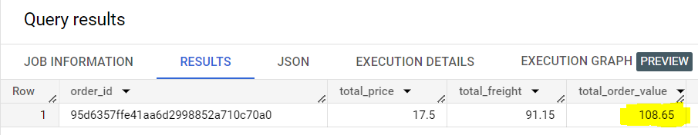

  SELECT

  order_id, payment_value

FROM

  `target.payments`

WHERE

  order_id = "95d6357ffe41aa6d2998852a710c70a0";

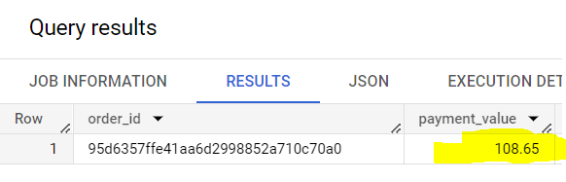

**2. In-depth exploration of dataset**

2.1 Is there a growing trend on e-commerce in Brazil? How can we describe a complete scenario?

Query:

SELECT

  time_period,

  order_count,

  ROUND((((order_count - LAG(order_count) OVER(ORDER BY t1.YEAR, t1.month)) / LAG(order_count) OVER(ORDER BY t1.YEAR, t1.month))* 100), 2) AS growth_percent

FROM (

  SELECT

    EXTRACT(YEAR

    FROM

      order_purchase_timestamp) AS year,

    EXTRACT(MONTH

    FROM

      order_purchase_timestamp) AS month,

    FORMAT_DATE('%b %Y', DATE(ORDER_PURCHASE_TIMESTAMP)) AS time_period,

    COUNT(order_id) AS order_count

  FROM

    `target.orders`

  WHERE

    order_status = "delivered"

  GROUP BY

    month, year, time_period) t1

ORDER BY

  year, month;

Result:

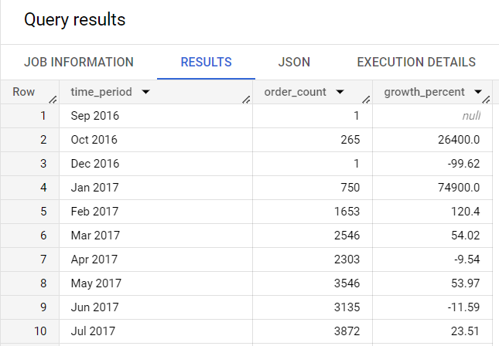

Can we see some seasonality with peaks at specific months?

No, as for some months data is showing orders of only 1 or 2 records and also there is huge spike in orders is seen in different months so we can/t comment on seasonality.

Overall business is in uptrend and sharp spike in orders in seen MoM basis.

2.2 What time do Brazilian customers tend to buy (Dawn, Morning, Afternoon or Night)?

Query:

SELECT

  temp.purchase_time,

  COUNT(*) AS total_orders

FROM (

  SELECT

    order_id,

    CASE

      WHEN TIME(order_purchase_timestamp) BETWEEN "00:00:00" AND "07:00:00" THEN "Dawn"

      WHEN TIME(order_purchase_timestamp) BETWEEN "07:00:01" AND "12:00:00" THEN "Morning"

      WHEN TIME(order_purchase_timestamp) BETWEEN "12:00:01" AND "18:00:00" THEN "Afternoon"

      WHEN TIME(order_purchase_timestamp) BETWEEN "18:00:01" AND "23:59:59" THEN "Night"

    END

    AS purchase_time

  FROM

    `target.orders`) TEMP

GROUP BY

  temp.purchase_time

ORDER BY

  total_orders DESC;

Result:

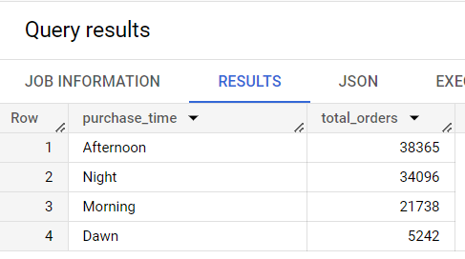

**Brazilian customers usually tend to buy in afternoon and night.**

**3. Evolution of E-commerce orders in the Brazil region:**

3.1 Get month on month orders by states

Query:

SELECT

  state , time_period , total_orders,

  LAG(total_orders) OVER(PARTITION BY state ORDER BY year, month ) AS prev_month_orders_count,

  ROUND(((total_orders - LAG(total_orders) OVER(PARTITION BY state ORDER BY year, month )) / LAG(total_orders) OVER(PARTITION BY state ORDER BY year, month))* 100,2) AS MoM_percent_growth

FROM (

  SELECT

    state,

    time_period,

    year,

    month,

    COUNT(*) AS total_orders

  FROM (

    SELECT

      o.order_id, o.order_purchase_timestamp,

      EXTRACT(YEAR FROM order_purchase_timestamp) AS year,

      EXTRACT(Month FROM order_purchase_timestamp) AS month,

      FORMAT_DATE('%b %Y', DATE(ORDER_PURCHASE_TIMESTAMP)) AS time_period,

      c.customer_state AS state

    FROM

      `target.orders` o

    JOIN

      `target.customers` c

    USING

      (customer_id)

    ORDER BY

       year, month) t1

  GROUP BY

    state, time_period,year, month) t2;

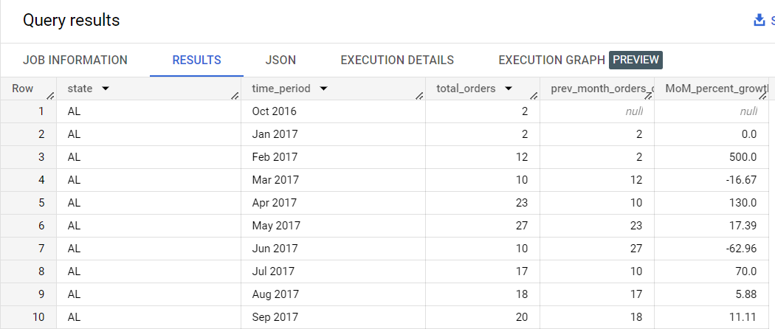

3.2 Distribution of customers across the states in Brazil

Query:

SELECT

  customer_state AS state,

  COUNT(*) AS total_customers

FROM

  `target.customers`

GROUP BY

  customer_state

ORDER BY

  total_customers DESC;

Result:

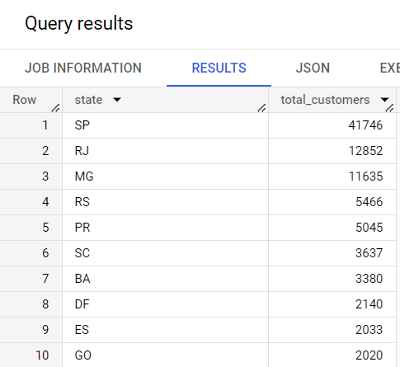

**4. Impact on Economy: Analyze the money movement by e-commerce by looking at order prices, freight and others.**

* 1. Get % increase in cost of orders from 2017 to 2018 (include months between Jan to Aug only) - You can use “payment_value” column in payments table

Query:

SELECT

  *,

  COALESCE((ROUND(((total_orders_value - LAG(total_orders_value) OVER(ORDER BY year))/LAG(total_orders_value) OVER(ORDER BY year))* 100, 2)), 0) AS percent_increase_YOY

FROM (

  SELECT

    year,

    ROUND(SUM(payment_value), 2) AS total_orders_value

  FROM (

    SELECT

      o.order_id,

      o.order_purchase_timestamp,

      EXTRACT(MONTH FROM o.order_purchase_timestamp) AS month,

      EXTRACT(YEAR FROM o.order_purchase_timestamp) AS year,

      p.payment_value

    FROM

      `target.orders` o

    JOIN

      `target.payments` p

    USING

      (order_id)

    WHERE

      o.order_status = "delivered")t1

  WHERE

    month BETWEEN 1

    AND 8

  GROUP BY

    year) t1

ORDER BY

  Year;

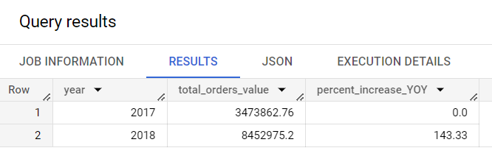

Comparison on Monthly total order value:

Query:

SELECT

  t2.Month_n_Year,

  t2.total_orders_value,

  ROUND(((t2.total_orders_value - LAG(total_orders_value) OVER(PARTITION BY month ORDER BY year))/LAG(total_orders_value) OVER(PARTITION BY month ORDER BY year))*100, 2) AS percent_increase

FROM (

  SELECT

    month,

    year,

    Month_n_Year,

    ROUND(SUM(payment_value)) AS total_orders_value

  FROM (

    SELECT

      o.order_id,

      o.order_purchase_timestamp,

      EXTRACT(month FROM o.order_purchase_timestamp ) AS month,

      EXTRACT(year FROM o.order_purchase_timestamp ) AS year,

      FORMAT_DATE('%b %Y', DATE(ORDER_PURCHASE_TIMESTAMP)) AS Month_n_Year,

      p.payment_value

    FROM

      `target.orders` o

    JOIN

      `target.payments` p

    USING

      (order_id)) t1

  WHERE

    month BETWEEN 1

    AND 8

  GROUP BY

    month, year, Month_n_Year

  ORDER BY

    month, year) t2

ORDER BY

  month;

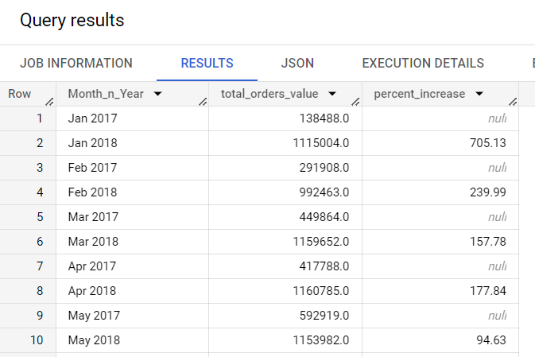

* 1. Mean & Sum of price and freight value by customer state

Query:

SELECT

  c.customer_state,

  ROUND(SUM(oi.price)) total_price,

  ROUND(AVG(oi.price)) avg_price,

  ROUND(SUM(oi.freight_value)) total_freight,

  ROUND(AVG(oi.freight_value)) avg_freight

FROM

  `target.order_items` oi

JOIN

  `target.orders` o

USING

  (order_id)

JOIN

  `target.customers` c

ON

  c.customer_id = o.customer_id

GROUP BY

  c.customer_state;

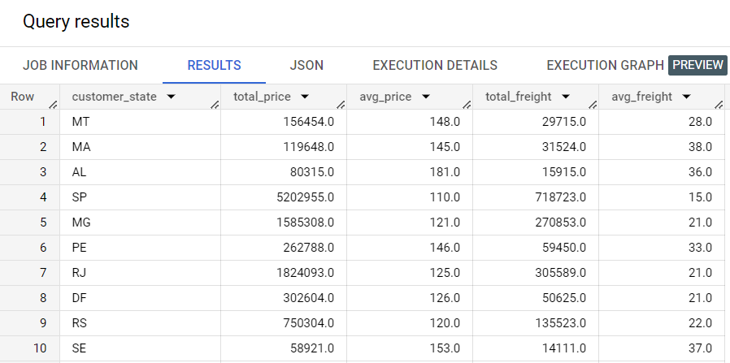

**5. Analysis on sales, freight and delivery time**

* 1. Calculate days between purchasing, delivering and estimated delivery

Query:

SELECT

  order_id,

  TIMESTAMP_DIFF(order_delivered_customer_date, order_purchase_timestamp, day) AS actual_delivery_time_in_days ,

  TIMESTAMP_DIFF(order_estimated_delivery_date, order_purchase_timestamp, day) AS estimated_delivery_time_in_days

FROM

  `target.orders`

WHERE

  order_status = "delivered";

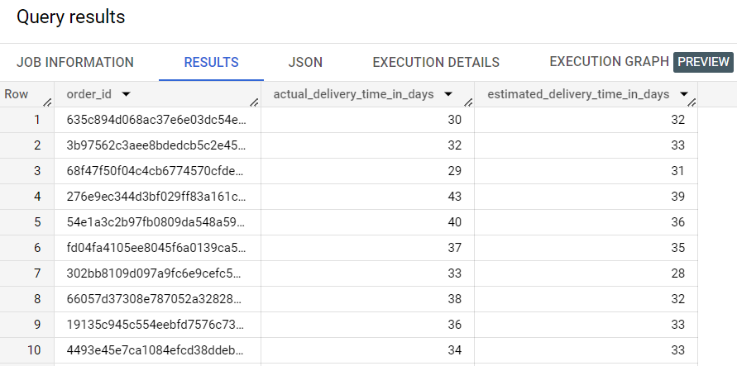

* 1. Find time_to_delivery & diff_estimated_delivery. Formula for the same given below:

time_to_delivery = order_delivered_customer_date-order_purchase_timestamp

diff_estimated_delivery = order_estimated_delivery_date-order_delivered_customer_date

SELECT

  TIMESTAMP_DIFF(order_delivered_customer_date, order_purchase_timestamp, day) AS time_to_delivery,

  TIMESTAMP_DIFF(order_estimated_delivery_date, order_delivered_customer_date, day) AS diff_estimated_delivery

FROM

  `target.orders`

WHERE

  order_status = "delivered";

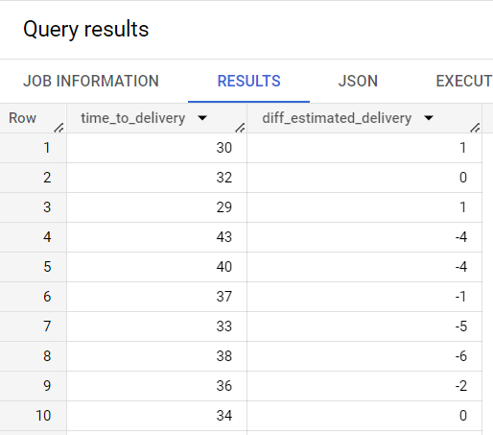

* 1. Group data by state, take mean of freight_value, time_to_delivery, diff_estimated_delivery

SELECT

  c.customer_state,

  ROUND(AVG(oi.freight_value),2) AS avg_freight_value,

  ROUND(AVG(o.time_to_delivery),2) AS avg_time_to_delivery,

  ROUND(AVG(o.diff_estimated_delivery),2) AS avg_diff_estimated_delivery

FROM

  `target.order_items` oi JOIN

( SELECT

    order_id, customer_id,

    TIMESTAMP_DIFF(order_delivered_customer_date, order_purchase_timestamp, day) AS time_to_delivery,

    TIMESTAMP_DIFF(order_estimated_delivery_date, order_delivered_customer_date, day) AS diff_estimated_delivery

  FROM

    `target.orders`

  WHERE

    order_status = "delivered") o

USING

  (order_id)

JOIN

  `target.customers` c

USING

  (customer_id)

GROUP BY

  customer_state;

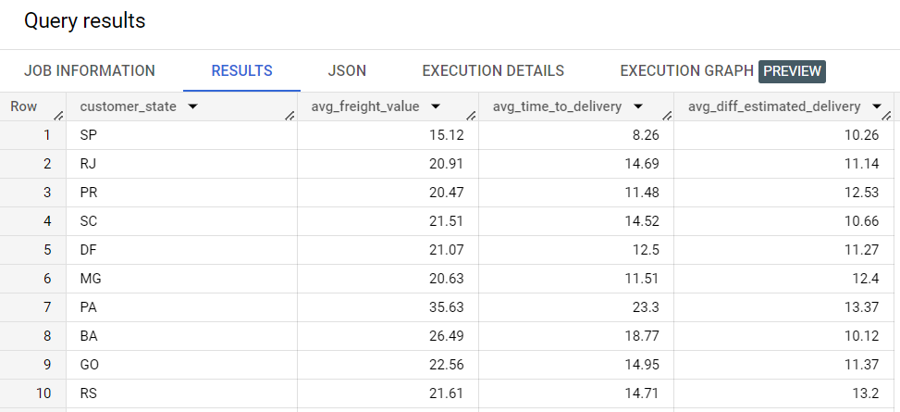

* 1. Sort the data to get the following: Top 5 states with highest/lowest average freight value - sort in desc/asc limit 5

States with Highest Avg freight value

SELECT

  customer_state

FROM (

  SELECT

    customer_state,

    ROUND(AVG(freight_value),2) AS avg_freight

  FROM

    `target.order_items` oi

  JOIN

    `target.orders` o

  USING

    (order_id)

  JOIN

    `target.customers` c

  USING

    (customer_id)

  GROUP BY

    customer_state

  ORDER BY

    avg_freight DESC) t1

LIMIT 5;

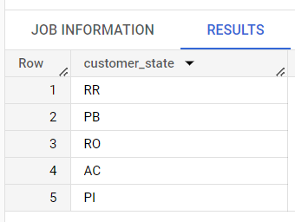

States with lowest Avg freight value

SELECT

  customer_state

FROM (

  SELECT

    customer_state,

    ROUND(AVG(freight_value),2) AS avg_freight

  FROM

    `target.order_items` oi

  JOIN

    `target.orders` o

  USING

    (order_id)

  JOIN

    `target.customers` c

  USING

    (customer_id)

  GROUP BY

    customer_state

  ORDER BY

    avg_freight ) t1

LIMIT 5;

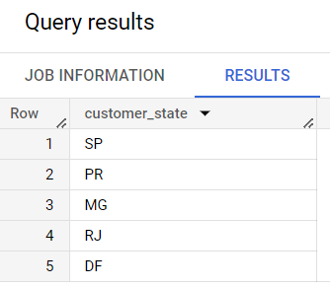

* 1. Top 5 states with highest/lowest average time to delivery

States with highest average time to delivery

SELECT

  customer_state

FROM (

  SELECT

    customer_state,

    ROUND(AVG(time_to_delivery),2) AS avg_delivery_time

  FROM (

    SELECT

      customer_state,

      TIMESTAMP_DIFF(order_delivered_customer_date, order_purchase_timestamp, day) AS time_to_delivery,

    FROM

      `target.orders` o

    JOIN

      `target.customers` c

    USING

      (customer_id)

    WHERE

      order_status = "delivered") t1

  GROUP BY

    customer_state

  ORDER BY

    avg_delivery_time DESC) t2

LIMIT 5;

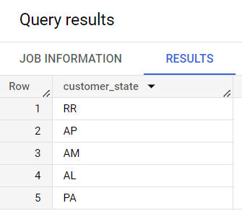

States with lowest average time to delivery

SELECT

  customer_state

FROM (

  SELECT

    customer_state,

    ROUND(AVG(time_to_delivery),2) AS avg_delivery_time

  FROM (

    SELECT

      customer_state,

      TIMESTAMP_DIFF(order_delivered_customer_date, order_purchase_timestamp, day) AS time_to_delivery,

    FROM

      `target.orders` o

    JOIN

      `target.customers` c

    USING

      (customer_id)

    WHERE

      order_status = "delivered") t1

  GROUP BY

    customer_state

  ORDER BY

    avg_delivery_time ) t2

LIMIT 5;

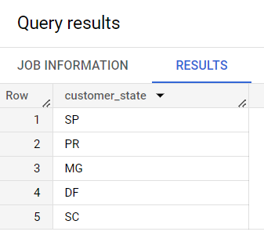

* 1. Top 5 states with really fast delivery compared to estimated date

SELECT

  customer_state,

  ROUND(AVG(estimated_delivery_time - actual_delivery_time), 2) AS delivery_time_difference

FROM (

  SELECT

    o.order_id,

    c.customer_state,

    TIMESTAMP_DIFF(order_delivered_customer_date, order_purchase_timestamp, day) AS actual_delivery_time,

    TIMESTAMP_DIFF(order_estimated_delivery_date, order_purchase_timestamp, day) AS estimated_delivery_time

  FROM

    `target.orders` o

  JOIN

    `target.customers` c

  USING

    (customer_id)

  WHERE

    order_status = "delivered") t1

GROUP BY

  customer_state

ORDER BY

  delivery_time_difference DESC

LIMIT 5;

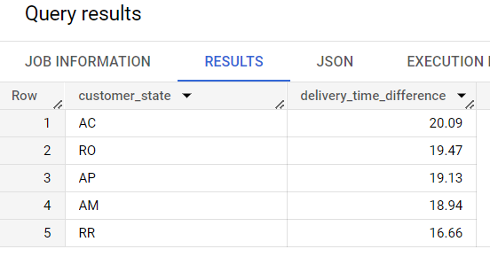

states with not so fast delivery compared to estimated date

SELECT

  customer_state,

  ROUND(AVG(estimated_delivery_time - actual_delivery_time), 2) AS delivery_time_difference

FROM (

  SELECT

    o.order_id,

    c.customer_state,

    TIMESTAMP_DIFF(order_delivered_customer_date, order_purchase_timestamp, day) AS actual_delivery_time,

    TIMESTAMP_DIFF(order_estimated_delivery_date, order_purchase_timestamp, day) AS estimated_delivery_time

  FROM

    `target.orders` o

  JOIN

    `target.customers` c

  USING

    (customer_id)

  WHERE

    order_status = "delivered") t1

GROUP BY

  customer_state

ORDER BY

  delivery_time_difference

LIMIT 5;

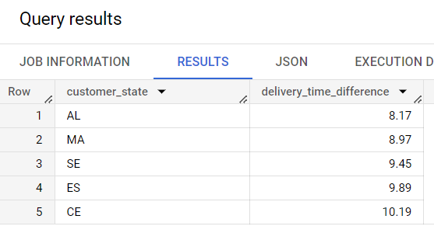

**6. Payment type analysis:**

* 1. Month over Month count of orders for different payment types

SELECT

  time_period,

  payment_type,

  COUNT(*) AS total_orders

FROM (

  SELECT

    p.order_id,

    p.payment_type,

    EXTRACT(YEAR FROM order_purchase_timestamp) AS year,

    EXTRACT(Month FROM order_purchase_timestamp) AS month,

    FORMAT_DATE('%b %Y', DATE(ORDER_PURCHASE_TIMESTAMP)) AS time_period

  FROM

    `target.payments` p

  JOIN

    `target.orders` o

  USING

    (order_id)) t1

GROUP BY

  time_period, payment_type, t1.YEAR, t1.month

ORDER BY

  t1.YEAR, t1.month ;

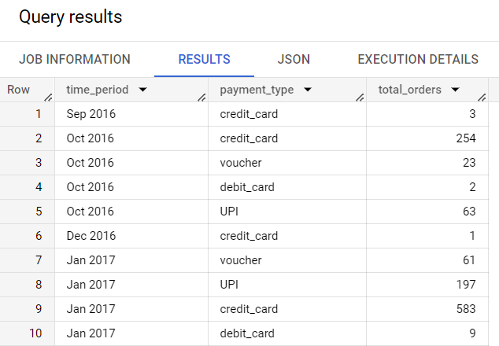

* 1. Count of orders based on the no. of payment installments

SELECT

  payment_installments,

  COUNT(*) AS total_orders

FROM

  `target.payments`

GROUP BY

  payment_installments;

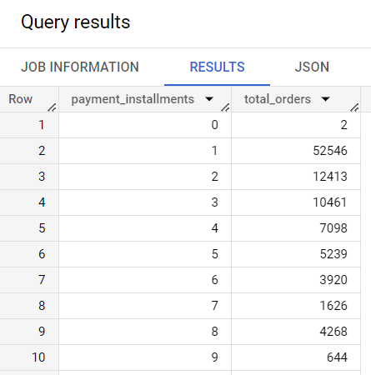

**7. Actionable Insights**

* Total 609 orders were unavailable and 625 orders were cancelled during the given time period, which makes it to be around 1.2 % of total orders.

We can reduce this number by studying the reasons behind order cancellation and items unavailability.

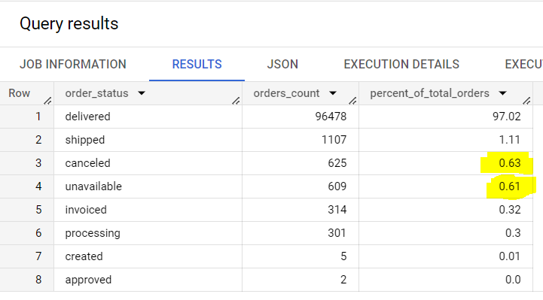

* We can see how the orders trajectory is showing very abrupt increase in orders volume with in very short time. Looking at overall trend, it is seen that business is picking up very fast in brazil so company has to be ready with extra workforce. To avoid high risk, it can consider hiring contractual employees.



* Company received low rating for maximum orders in highlighted states; need to study further about the reasons for customer dissatisfaction to such great extent in these states.

This is the query for counting the number of rating in each state.

SELECT

  *

FROM (

  SELECT

    c.customer_state,

    orv.review_score

  FROM

    `target.order_reviews` orv

  JOIN

    `target.orders` o

  USING

    (order_id)

  JOIN

    `target.customers` c

  USING

    (customer_id)) PIVOT(COUNT(*) FOR review_score IN (1, 2, 3, 4, 5));

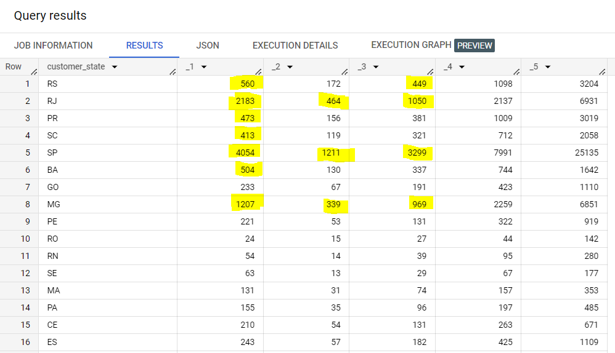

**8. Recommendations**

* As Brazilian customers usually tend to buy in afternoon and night, we can increase staff in during this time frame in order to manage the customers’ requests, and services better during this time by reducing workforce of morning and dawn.
* We can see, only 3 state contribute for maximum volume, and rest of the state need to be focused for improving the business.

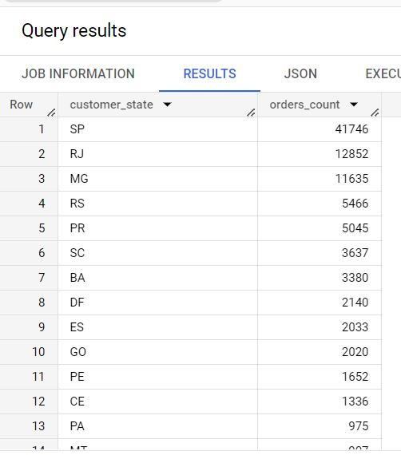

* Avg delivery time is quite high for most of those states from where company is receiving quite less volume of orders, detailed study is needed further for checking the other reasons behind such low volume of orders from majority of states. Huge delivery time can be the one of the reason and need to work on it.

States with highest average delivery time -

